From: Chan Pei Fong [mailto:pei-fong.chan@schenker.com]
Sent: Tuesday, 07 October, 2008 10:58 AM
To: 'Kenny Goh'
Cc: 'Lily'; 'DavidGH Lim'
Subject: RE: Pick LIst show Partial/BreakBulk needed
Hi Kenny,

below new Pick List with added alert messages when there's partial shipment.
LP is partial allocated and the LP still have inventory balance.

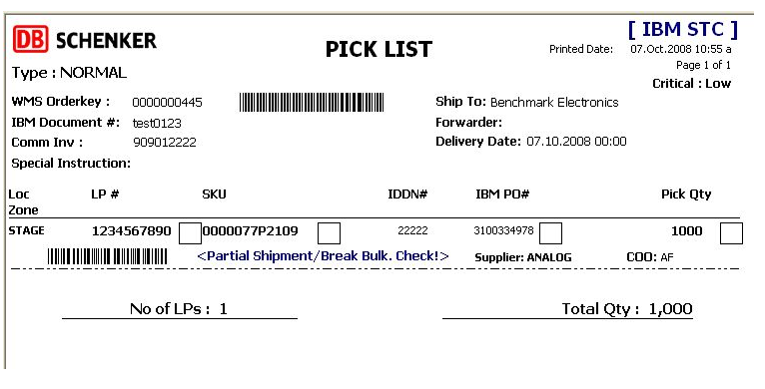

From: Kenny Goh [mailto:kenny.goh@schenker.com]
Sent: Thursday, 02 October, 2008 3:58 PM
To: 'Chan Pei Fong'
Cc: 'Lily'; 'DavidGH Lim'
Subject: RE: Pick LIst show Partial/BreakBulk needed
Hi Pei Fong

STC will have this enhancement.

Warning message:

<Partial Shipment/Break Bulk. Check!>

Best Regards
Kenny Goh
Schenker Singapore
17 Changi South Street 2
SLC 2 Level 1 S486129
DID: (65) 65491133
Fax (65) 65465809
Email: kenny.goh@schenker.com

From: PeiFong [mailto:pei-fong.chan@schenker.com]
Sent: Monday, 15 September, 2008 1:33 PM
To: 'Ivy Soh'
Subject: RE: Western Geco Overshipment - DO# N20080784A
Ivy,

it only prompt when there's balance in inventory.

From: Ivy Soh [mailto:ivy.soh@schenker.com]
Sent: Monday, 15 September, 2008 12:43 PM
To: 'PeiFong'
Subject: RE: Western Geco Overshipment - DO# N20080784A
Hi Pei fong,

What if all orders in LP# L9800020 is assigned, will it still prompt breakbulk?

or will it only prompt if there are balance in the inventory?

From: PeiFong [mailto:pei-fong.chan@schenker.com]
Sent: Monday, September 15, 2008 11:58 AM
To: ivy.soh@schenker.com
Cc: ah-fun.wong@schenker.com
Subject: RE: Western Geco Overshipment - DO# N20080784A
Hi Ivy,

I've added below message "Partial/Breakbulk needed' for LP that is partial allocated.

below sample snapshot from test environment.
